­­



**Authorized Signature:**

**Mr. Le Van Long**

**Date of Issued:**  *27/08/2012*

--------🙟🟑🙝--------

**PROJECT SPECIFICATION**

**(TUNGA)**

--------🙟🟑🙝--------

**Mr./Ms.:**

1. **Ho Hinh Phu- Student503702**
2. **Vong Khi Dau – Student503701**
3. **Nguyen Hoai Nam – Student503785**
4. **Le Quy Toan – Student503651**

**Submitted By:**

**Mr.Vong Khi Dau**

**REVIEW 1**

***Chapter I: Problem Definition***

1. *Problem Statement:*

FUN ‘N’ FOOD is a big name in the hospitality business (Hotels & Resorts) and has a very successful independent chain of restaurants ***TUNGA*** in the country***.*** *TUNGA restaurants* are known for their wide range of continental cuisine and consummate style.

*TUNGA* provides range fully-equipped, private meeting rooms, and regal banquet halls which offer the perfect combination of efficiency and convenience. They are also popular among school & college students for range of bakery & fast food products.

With increasing popularity and the customer base, organization has decided to go techno savvy to meet customer expectations with respect to its exclusive services in the market.

Organization has decided to reach out to its customers via online services through a web site on the internet.

The web site talks about other business aspects of the firm and has online reservation and home delivery service as one of its premium services.

**However you are essentially required to focus on the online booking and the home delivery aspect only and to design and build a site which deals with the same.**

1. *Existing Scenario:*

Depending on the powers login. That the site will serve specific functions.

For example:

* Customer: login to book a room, book a table, order food online. Search Hotel & Restaurant Information of TUNGA system. Look event’s picture and clip.
* Administrators manage the entire system. Staff management book room, book table create New Customer Account…

*C****hapter II: Requirement Specification***

1. *Customer Specifications:*

This site should allow customer to choose the services offered by the restaurant :

1. Online table reservation in the restaurant for specific date and time. This will

* Provide the list of restaurants in the country so that the user can choose accordingly.
* Provide the list of tables available for online reservation at different dining rooms in the restaurant.
* Mention the number of guests that can be accommodated on the particular table.
* Accept the booking for tables.
* Online table reservations are done 6hrs in advance for the current date.
* Table reservation can be done up to one month in advance.
* Give a token number to the customer as an acknowledgement of booking.

1. Online order for food under restaurant’s exclusive home delivery service.

* This facility is valid for 24hrs. from the time of order.
* Accept the customer’s order so that the nearest restaurant can service the order in stipulated time (60 - 120 Minutes).
* Record the customer’s name, residence address and contact numbers and other vital details if required.
* Facilitate with the choice of food keeping Vegetarian and non-vegetarian customers in mind.
* Provide the menu list with their price tags accordingly and also mention the number of persons that can be served with one unit of order. This will help the customer to decide the quantity to be ordered.
* Display the list items select from the menu and exact amount (itemized bill) that the customer is supposed to pay (inclusive of all taxes applicable).
* Give a token number as an acknowledgement to the customer that the order has been noted down by the restaurant.
* Show the approximate time (in minutes) in which the ordered will be delivered to the customer.

1. The site should have the appropriate look and feel suitable to the restaurant’s reputation and status.

* **Mainly Input/ Output**
  + - Login :
      * Input: username,password
      * Output: successful or unsuccessful
* Search Information:
  + - Input:address, datetime,money,category…
    - Output:Information of property…
* Search Hotel & Restaurant through Google API
  + - Input: address
    - Output: location of Hotel & restaurant in Gmap
* Book Room & Tables:
  + - Input: Customer’s information and Room request information.
    - Output: Message Success, send Email to Customer
* **Administrator** **Page**:
  + - Admin Login :
      * Input: username,password
      * Output: successful or unsuccessful
    - Management of user&Staff information:
      * Input: UserName, Address…
      * Output: Information of User.
    - Create New Accoutn:
      * Input: User’s Information
      * Output: Message Success

1. *Technical System requirements*

* **Developer:**
* Hardware
* Intel® Core™Duo CPU 1.60GHz, 1,00GB of RAM or higher
* Windows XP, Windows Vista or Windows 7
* Software
* NetBeans 7.1.2 /Eclipse juno
* SQL Server 2008
* Internet Explorer 8.0
* Mozilla Firefox 3.6
* Google Chrome 8.0
* Photoshop CS5
* Lib
* sqljdbc4
* primefaces
* primefaces themes
* Google Api
* **User:**
* Hardware
* Intel® Core™Duo CPU 1.60GHz
* 1,00GB of RAM or higher
* Software
* Internet Explorer 7.0
* Mozilla Firefox 3.6
* Google Chrome 8.0
* Windows XP, Windows Vista or Windows 7

***Chapter III: Architecture and Design Project***

1. *Tiers of Application*

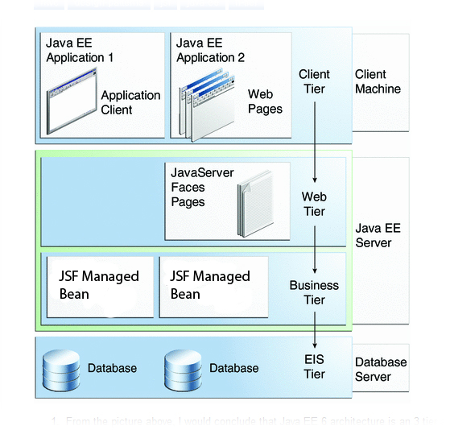

1. *Design project by DFD/UML*

* **Define DFD**

Data Flows Diagram (DFD) describes the information flow in the system. The next step of system analysis is to consider in detail the information necessary for the implementation for functions discussed above and the one necessary for the improvement of the functions. Modeling tool frequently used for this purpose is DFD. DFD will support 4 main activities.

* **Analysis**

DFD is used to determine requirement of users.

* **Design**

DFD is used to map out plan and illustrate solution to analysis and users while designing a new system.

* **Communication**

One of the strength of DFD is its simplicity and ease to understand to analysts and users.

* **Document**

DFD is used to provide special description of requirement and system design. DFD provide an overview of key functional components of the system but it does not provide any detail on these components. We have to use other tools like database dictionary, process specification to get an idea of which information will be exchanged and how.

**The main Component of Context Diagram**

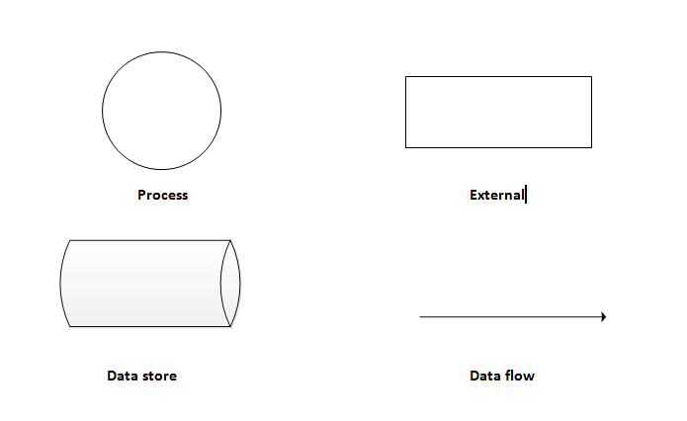

1. **USECASE DIAGRAM:**

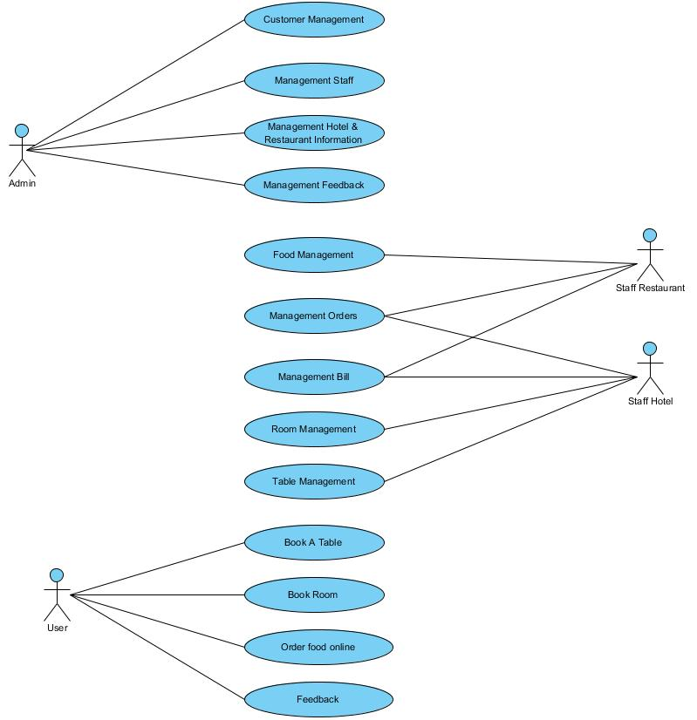 **DESCRIPTION USECASE:**

|  |  |  |  |
| --- | --- | --- | --- |
| **Use case name**: Customer Manager(create new account, update account…) | **ID**: 1 | | **Important level**: High |
| **Primary actor**: Database Administrator | | **Use case type**: Detail, necessary | |
| **Stakeholders and interests**: Customer wants to use the system. Database administrator created Accounts… | | | |
| **Brief description**: Describe the creation account, and add new facilities | | | |
| **Trigger**: Database Administrator.  **Type**: | | | |
| **Relationships**:  Association: Database Administrator.  Include:  Extend:  Generalization: | | | |
| **Normal flow of events**:   1. Login in system 2. Create New User Account. 3. Create Notice to Person | | | |
| **Sub flows**: | | | |
| **Alternate/exceptional flows**:  Admin are only entered incorrectly 3 times | | | |

|  |  |  |  |
| --- | --- | --- | --- |
| **Use case name**: Manager Staff(create new account, update account…) | **ID**: 2 | | **Important level**: High |
| **Primary actor**: Database Administrator | | **Use case type**: Detail, necessary | |
| **Stakeholders and interests**: Staff wants to use the system. Database administrator created Accounts… | | | |
| **Brief description**: Describe the creation account, and add new facilities | | | |
| **Trigger**: Database Administrator.  **Type**: | | | |
| **Relationships**:  Association: Database Administrator.  Include:  Extend:  Generalization: | | | |
| **Normal flow of events**:   1. Login in system 2. Create New User Account. 3. Create Notice to Person | | | |
| **Sub flows**: | | | |
| **Alternate/exceptional flows**:  Admin are only entered incorrectly 3 times | | | |

|  |  |  |  |
| --- | --- | --- | --- |
| **Use case name**: Manager Hotel & Restaurant(create new, update, or Delete…) | **ID**: 3 | | **Important level**: High |
| **Primary actor**: Database Administrator | | **Use case type**: Detail, necessary | |
| **Stakeholders and interests**: Hotels& Restaurant wants to show on the system. Database administrator created … | | | |
| **Brief description**: Describe the creation account, and add new facilities | | | |
| **Trigger**: Database Administrator.  **Type**: | | | |
| **Relationships**:  Association: Database Administrator.  Include:  Extend:  Generalization: | | | |
| **Normal flow of events**:   1. Login in system 2. Create New Hotel & restaurant. | | | |
| **Sub flows**: | | | |
| **Alternate/exceptional flows**:  Admin are only entered incorrectly 3 times | | | |

|  |  |  |  |
| --- | --- | --- | --- |
| **Use case name**: Manager Feedbacks | **ID**: 4 | | **Important level**: High |
| **Primary actor**: Database Administrator | | **Use case type**: Detail, necessary | |
| **Stakeholders and interests**: Customs feedback. And Admin check | | | |
| **Brief description**: Describe the creation account, and add new facilities | | | |
| **Trigger**: Database Administrator.  **Type**: | | | |
| **Relationships**:  Association: Database Administrator.  Include:  Extend:  Generalization: | | | |
| **Normal flow of events**:   1. Login in system 2. Check feedbacks. | | | |
| **Sub flows**: | | | |
| **Alternate/exceptional flows**:  Admin are only entered incorrectly 3 times | | | |

|  |  |  |  |
| --- | --- | --- | --- |
| **Use case name**: Food Manager | **ID**: 5 | | **Important level**: Medium |
| **Primary actor**: Staff Restaurant | | **Use case type**: Detail, | |
| **Stakeholders and interests**: Staff Restaurant | | | |
| **Brief description**: Create, update, delete | | | |
| **Trigger**: Staff Restaurant  **Type**: | | | |
| **Relationships**:  Association: Staff Restaurant  Include:  Extend:  Generalization: | | | |
| **Normal flow of events**:  1/ Login in system  2/ Choose action Food Manager.  3/ Action with request | | | |
| **Sub flows**: | | | |
| **Alternate/exceptional flows**: | | | |

|  |  |  |  |
| --- | --- | --- | --- |
| **Use case name**: Manager Orders | **ID**: 6 | | **Important level**: Medium |
| **Primary actor**: Staff Restaurant, Staff Hotel | | **Use case type**: Detail, | |
| **Stakeholders and interests**: Staff Restaurant | | | |
| **Brief description**: Create, Update, Delete | | | |
| **Trigger**: Staff Hotel  **Type**: | | | |
| **Relationships**:  Association: Staff Restaurant  Include:  Extend:  Generalization: | | | |
| **Normal flow of events**:  1/ Login in system  2/ Choose action Manager Orders  3/ Action with request’s system. | | | |
| **Sub flows**: | | | |
| **Alternate/exceptional flows**: | | | |

|  |  |  |  |
| --- | --- | --- | --- |
| **Use case name**: Manager Bill | **ID**: 7 | | **Important level**: Medium |
| **Primary actor**: Staff Restaurant, Staff Hotel | | **Use case type**: Detail, | |
| **Stakeholders and interests**: Staff Hotel | | | |
| **Brief description**: Staff Restaurant | | | |
| **Trigger**: Staff Restaurant  **Type**: | | | |
| **Relationships**:  Association: Staff Restaurant  Include:  Extend:  Generalization: | | | |
| **Normal flow of events**:  1/ Login in system  2/ Choose action Manager Bill | | | |
| **Sub flows**: | | | |
| **Alternate/exceptional flows**: | | | |

|  |  |  |  |
| --- | --- | --- | --- |
| **Use case name**: Room Manager and Table Manager | **ID**: 8 | | **Important level**: Medium |
| **Primary actor**: Staff Hotel | | **Use case type**: Detail, | |
| **Stakeholders and interests**: Staff Hotel | | | |
| **Brief description**: : Room Manager and Table Manager | | | |
| **Trigger**: Staff Hotel **Type**: | | | |
| **Relationships**:  Association: Staff Hotel Include:  Extend:  Generalization: | | | |
| **Normal flow of events**:  1/ Login in system  2/ Choose action : Room Manager or Table Manager | | | |
| **Sub flows**: | | | |
| **Alternate/exceptional flows**: | | | |

|  |  |  |  |
| --- | --- | --- | --- |
| **Use case name**: Bookings and feedbacks | **ID**: 9 | | **Important level**: Medium |
| **Primary actor**: Customers | | **Use case type**: Detail, | |
| **Stakeholders and interests**: Customers | | | |
| **Brief description**: : Bookings and feedbacks | | | |
| **Trigger**: Customers  **Type**: | | | |
| **Relationships**:  Association: Customers  Include:  Extend:  Generalization: | | | |
| **Normal flow of events**:  1/ Login in system  2/ Choose action : Bookings and feedbacks | | | |
| **Sub flows**: | | | |
| **Alternate/exceptional flows**: | | | |

1. **ACTIVITY DIAGRAM:**

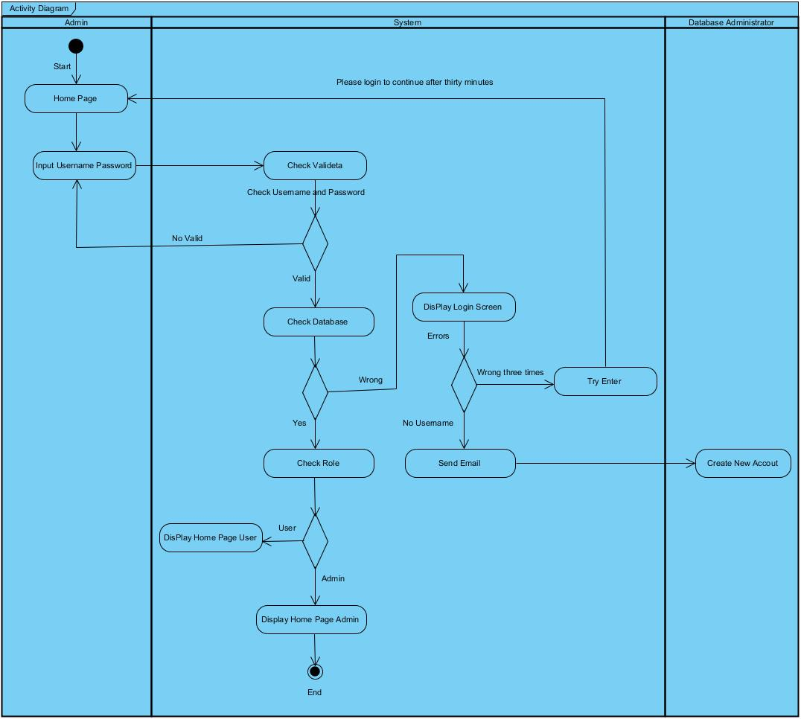

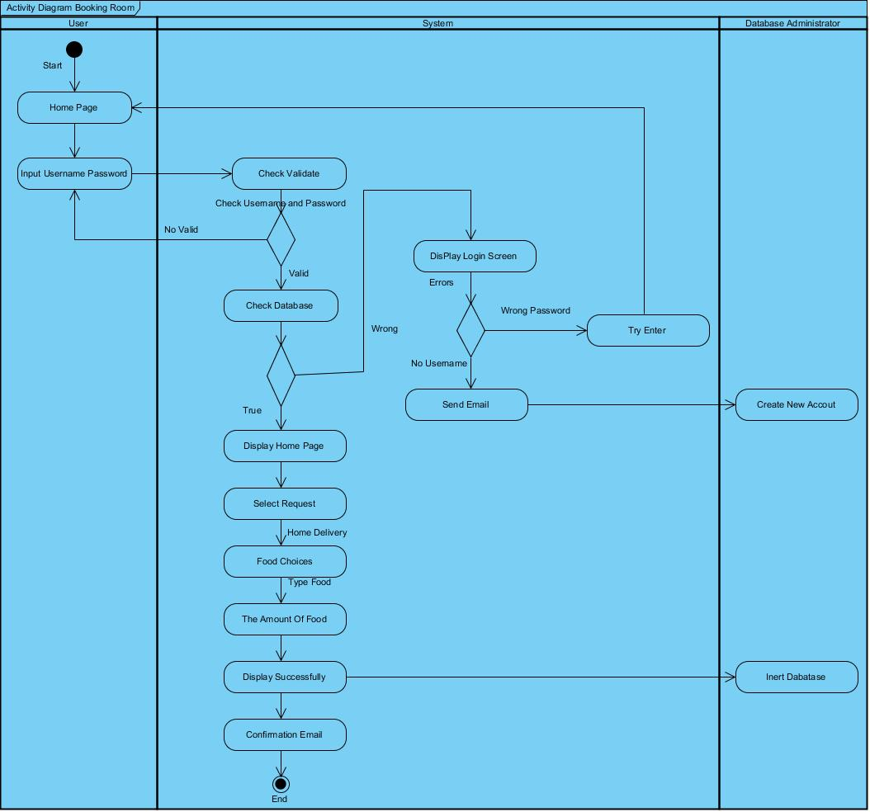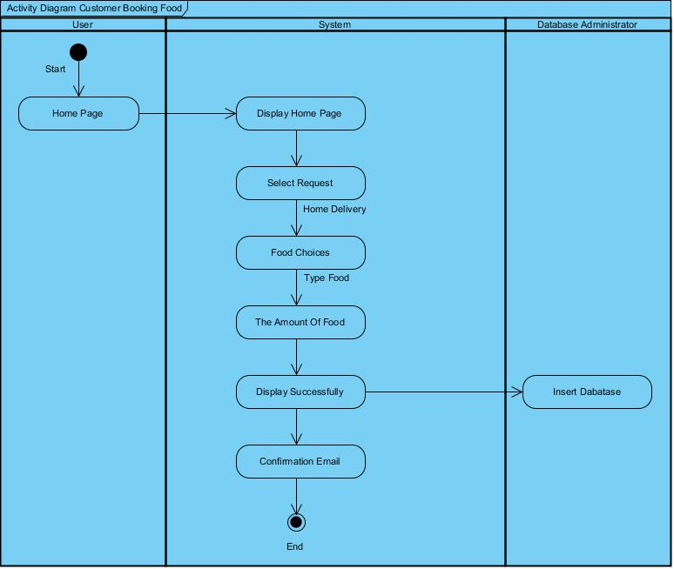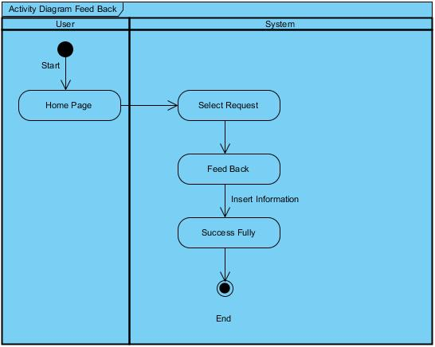

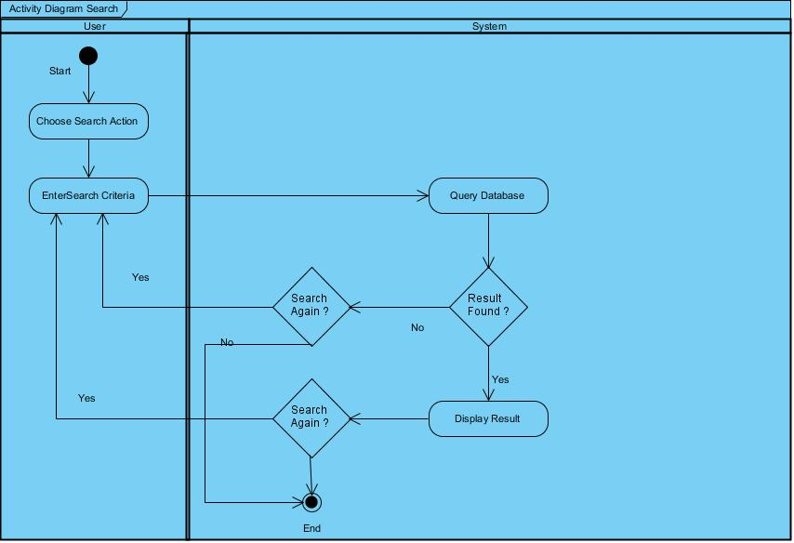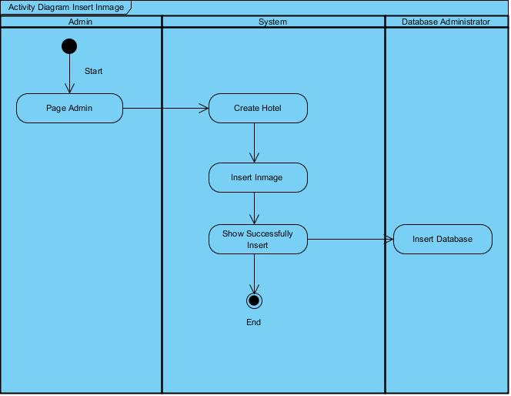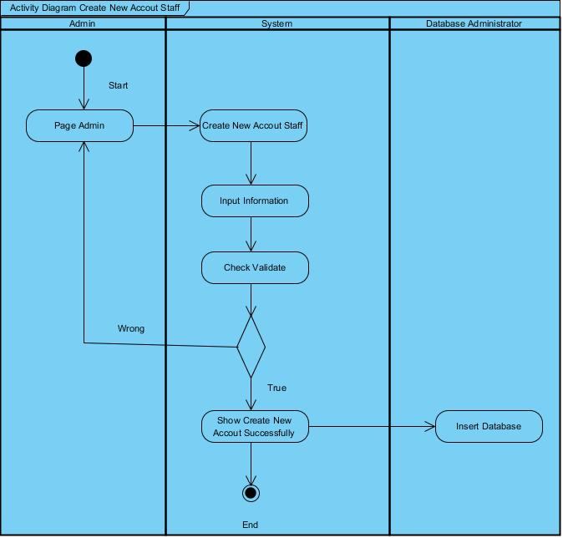

# SEQUENCE DIAGRAM:

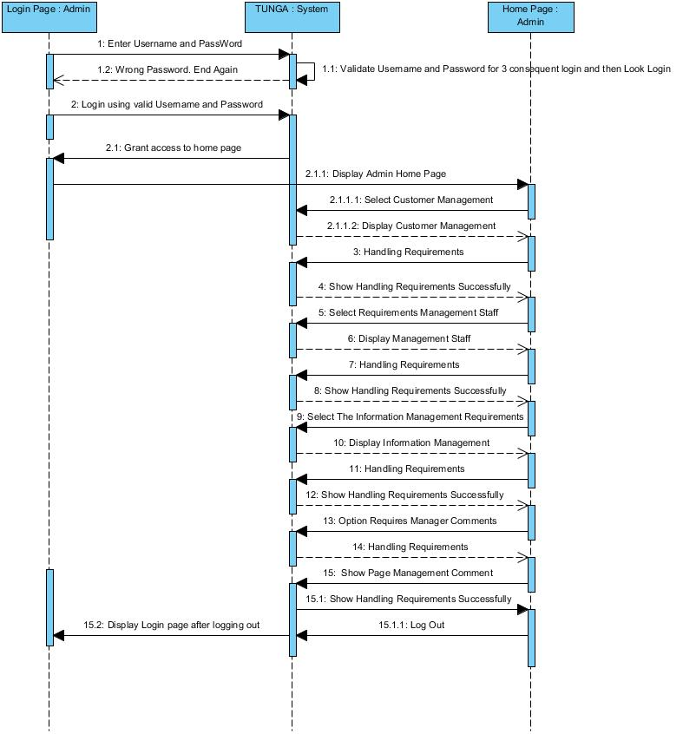

|  |  |  |
| --- | --- | --- |
| Sequence Diagram Name | Login Page: Admin | |
| Actors | Admin | |
| Description | Admin must login to TUNGA system before doing anything. | |
| Requirements | Admin must provide user name and password. | |
| Pre-conditions | N/A | |
| Post-conditions | Move actor to Admin home page. | |
| Basic flow | Admin actions :  1 – Admin must input username , password  2 - Admin click on Login button | System response :  3 - System would validate information  4 – System redirect End User home page. |
| Alternative flow | N/A | N/A |
| Exception | N/A | N/A |
|  |  |  |

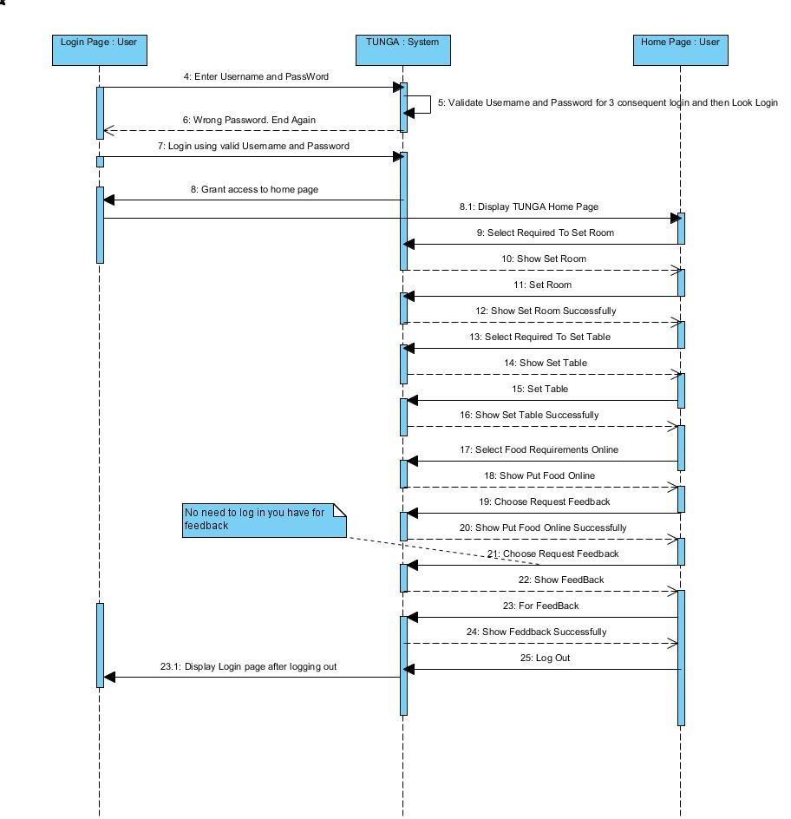

|  |  |  |
| --- | --- | --- |
| Sequence Diagram Name | Login Page: User | |
| Actors | User | |
| Description | User must login to TUNGA system before doing anything. | |
| Requirements | User must provide user name and password. | |
| Pre-conditions | N/A | |
| Post-conditions | Move actor to User home page. | |
| Basic flow | User actions :  1 –User must input username , password  2 - User click on Login button | System response :  3 - System would validate information  4 – System redirect End User home page. |
| Alternative flow | N/A | N/A |
| Exception | N/A | N/A |
|  |  |  |

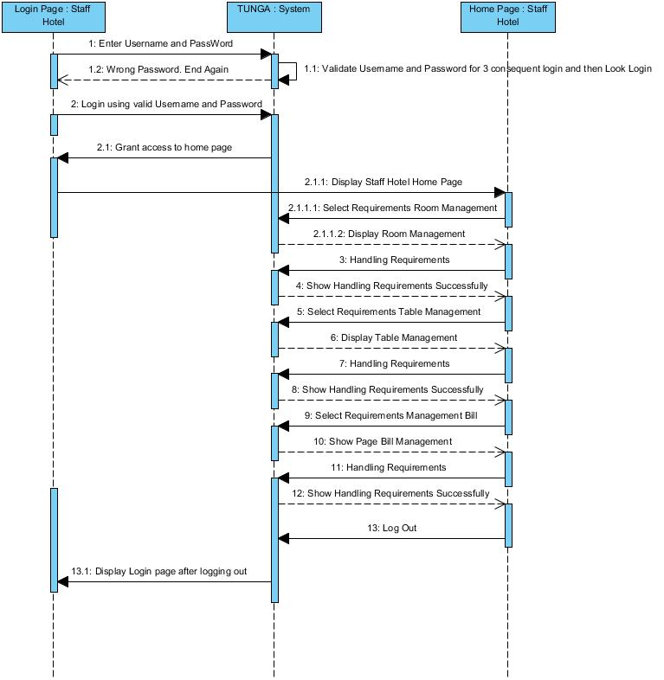

|  |  |  |
| --- | --- | --- |
| Sequence Diagram Name | Login Page: Staff Hotel | |
| Actors | Staff Hotel | |
| Description | Staff Hotel must login to TUNGA system before doing anything. | |
| Requirements | Staff Hotel must provide user name and password. | |
| Pre-conditions | N/A | |
| Post-conditions | Move actor to Staff Hotel home page. | |
| Basic flow | Staff Hotel actions :  1 – Staff Hotel must input username , password  2 - Staff Hotel click on Login button | System response :  3 - System would validate information  4 – System redirect End User home page. |
| Alternative flow | N/A | N/A |
| Exception | N/A | N/A |
|  |  |  |

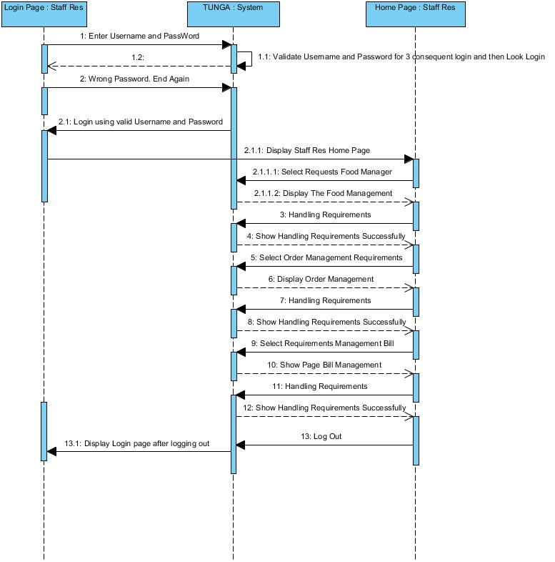

|  |  |  |
| --- | --- | --- |
| Sequence Diagram Name | Login Page: Staff Res | |
| Actors | Staff Res | |
| Description | Staff Res must login to TUNGA system before doing anything. | |
| Requirements | Staff Res must provide user name and password. | |
| Pre-conditions | N/A | |
| Post-conditions | Move actor to Staff Res home page. | |
| Basic flow | End User actions :  1 – Staff Res must input username , password  2 - Staff Res click on Login button | System response :  3 - System would validate information  4 – System redirect End User home page. |
| Alternative flow | N/A | N/A |
| Exception | N/A | N/A |
|  |  |  |

***Chapter IV: Entity Relationship and Database Design/Structure:***

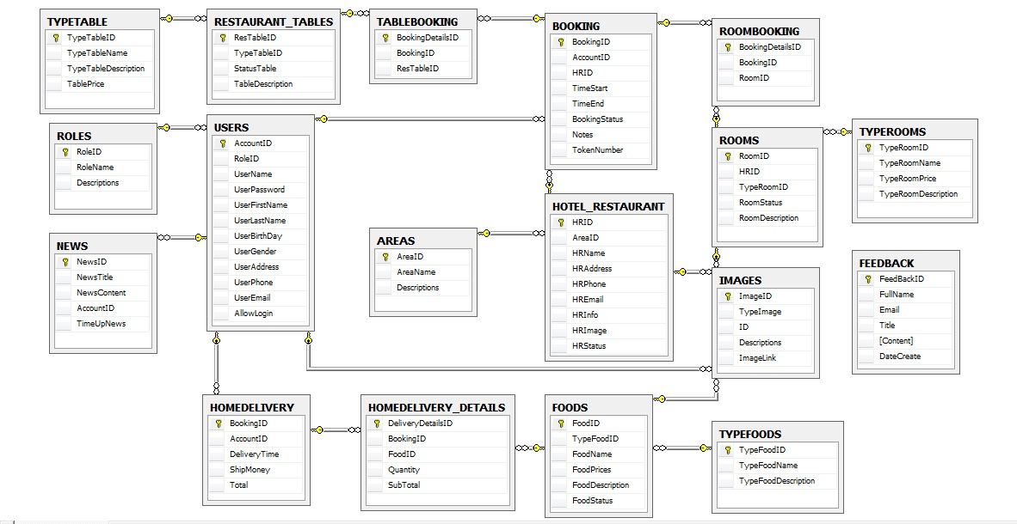

*Database:*

1. Table “Areas:



1. Tables “Booking”:



1. Tables “Feedback”:

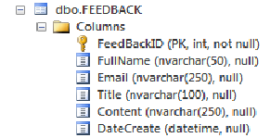

1. Tables “Foods”:

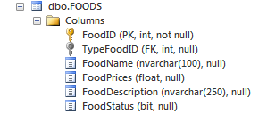

1. Tables “HomeDeLivery”

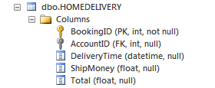

1. Tables “HomeDelivery_Details”

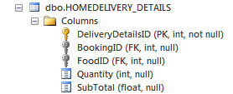

1. Tables “Hotel_Restaurant”

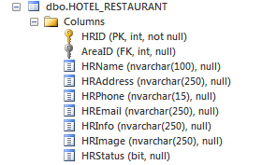

1. Tables “Images”

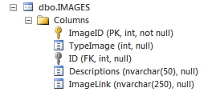

1. Tables “News”

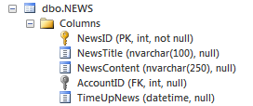

1. Tables “Restaurant_Tables”

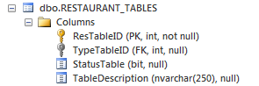

1. Tables “Roles”

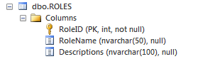

1. Tables “RoomBooking”

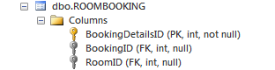

1. Tables “Rooms”

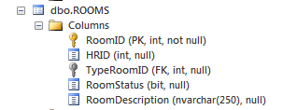

1. Tables “TableBooking”

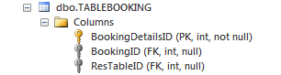

1. Tables “TypeFoods”

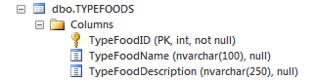

1. Tables “TypeRooms”

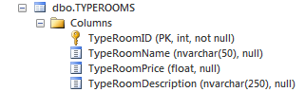

1. Tables “TypeTables”

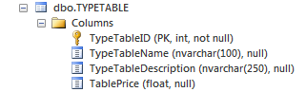

1. Tables “Users”

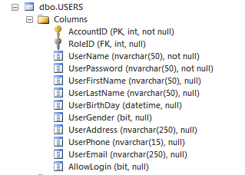

***Chapter V: The Main Interface Of eProject***

1. Admin:
2. Role Manager:

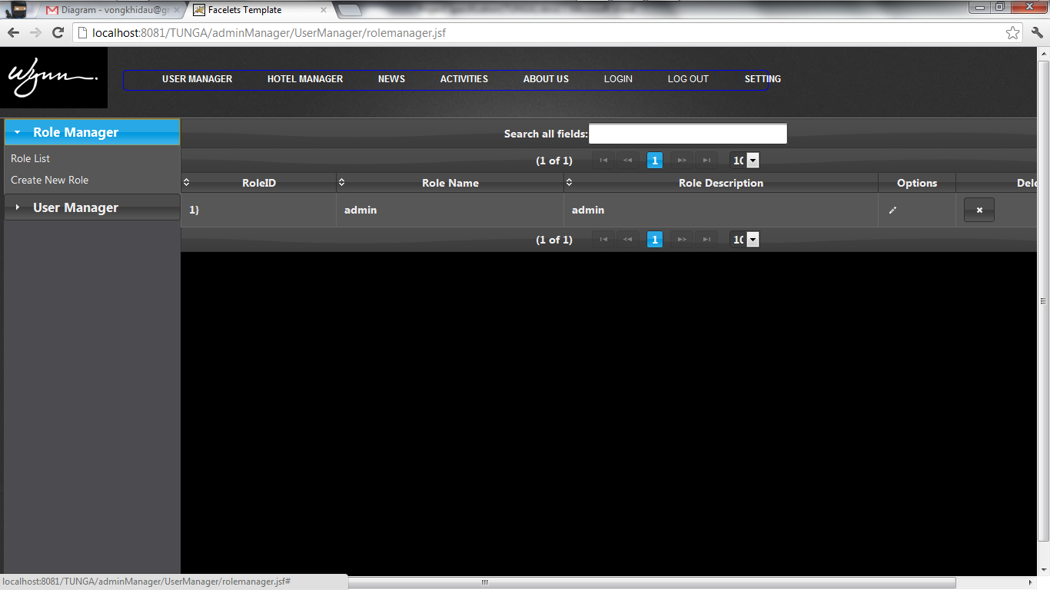

1. Create Role

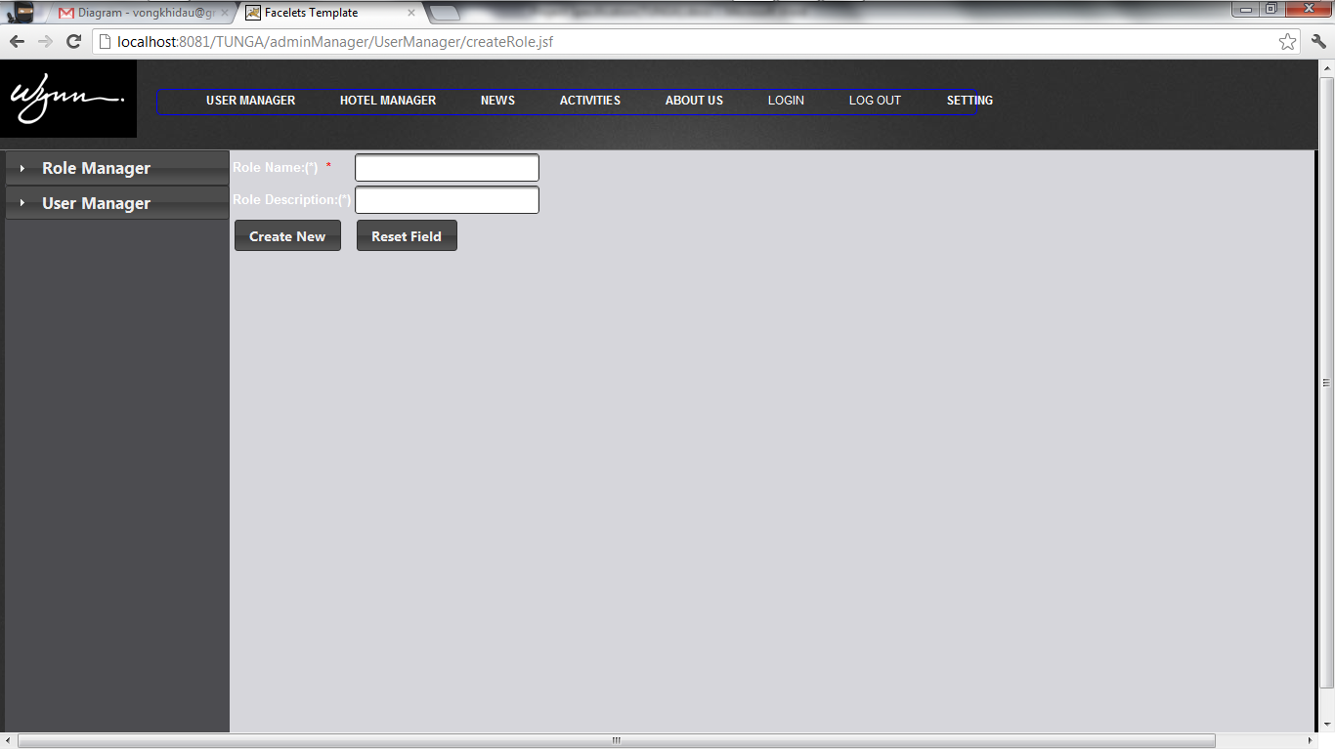

3.User Manager:

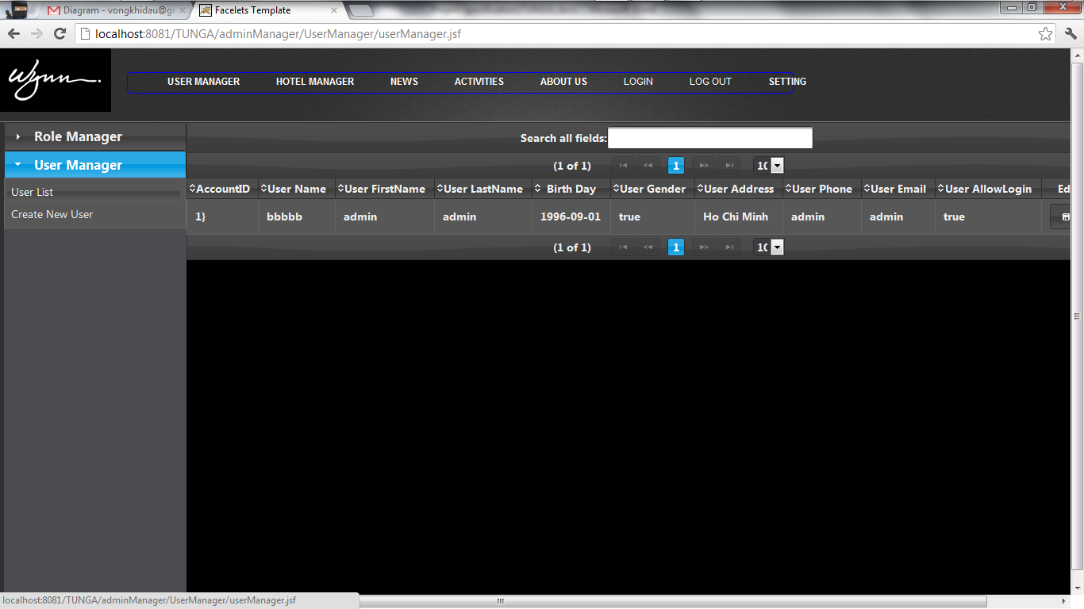

4.Create User:

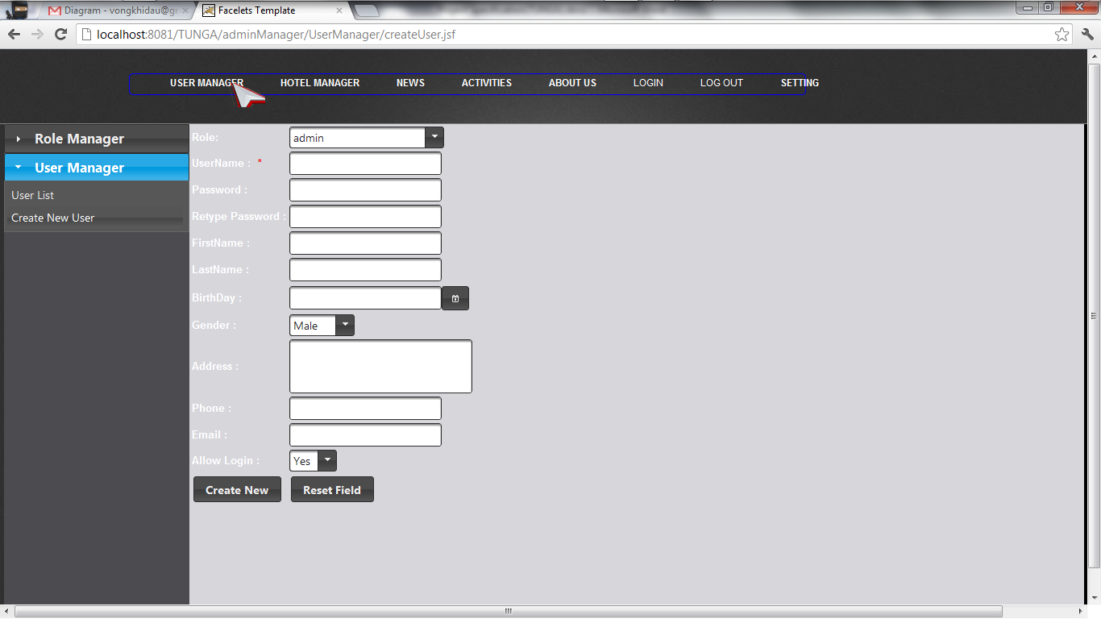

5.Create New Hotel

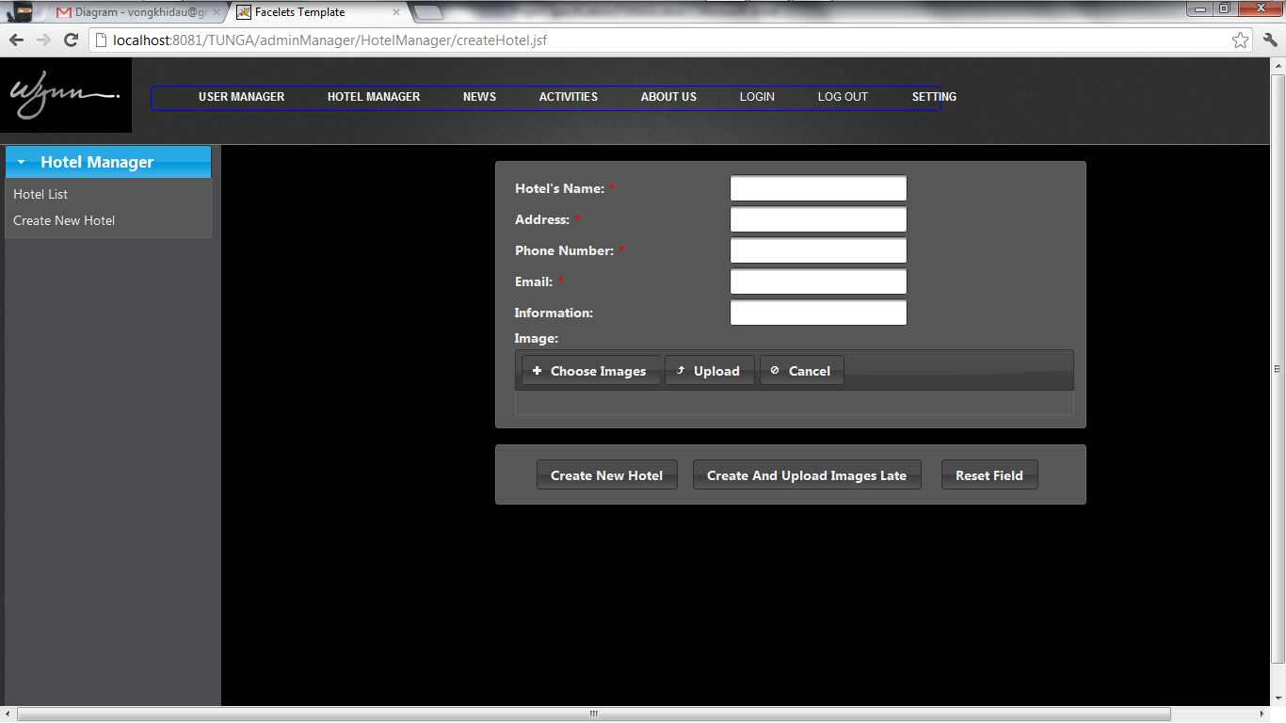

1. Index

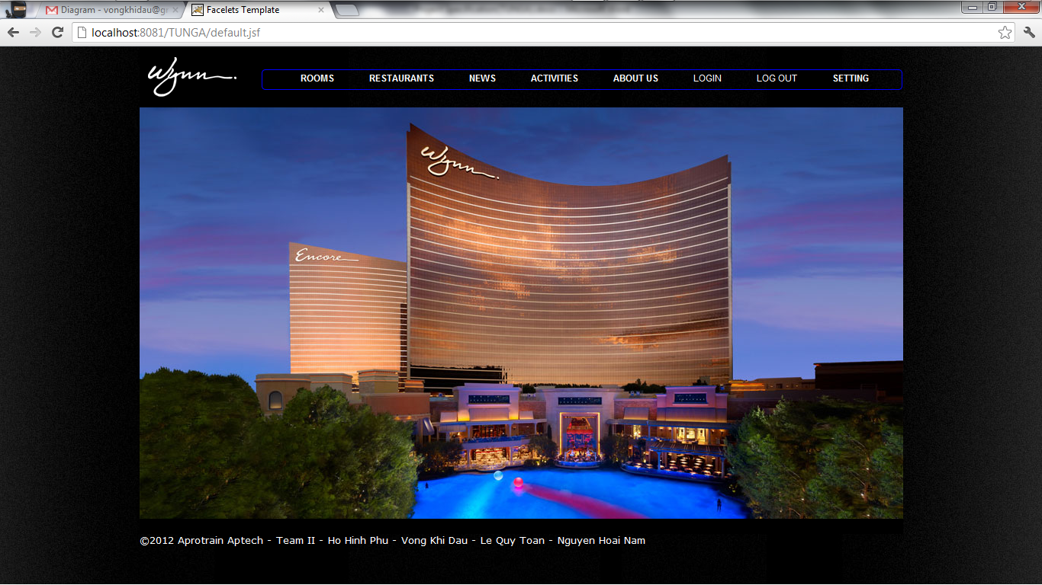

Tast Sheet:

|  |  |  |  |  |  |  |  |
| --- | --- | --- | --- | --- | --- | --- | --- |
| Project Ref No: | | Project Title | Activity  Plan repared by: | Date of Reparation of Activities | | | |
| Sr.No | Task | Actual StartDate | Actual Days | Team Member Name | Status |
| 1 | Project Definition | TUNG A |  |  | 3 | Vong Khi Dau  Ho Hinh Phu  Nguyen Hoai Nam  Le Quy Toan | Completed |
| 2 | Customer Requirement Specification |  |  | 3 | Vong Khi Dau  Ho Hinh Phu  Nguyen Hoai Nam  Le Quy Toan | Completed |
| 3 | Entity Relationhip Diagram(ERD) |  |  | 4 | Vong Khi Dau  Le Quy Toan | Completed |
| 4 | Database design/structure |  |  | 5 | Vong Khi Dau  Ho Hinh Phu  Le Quy Toan | Completed |
| 5 | Architecture and Design project |  |  | 2 | Vong Khi Dau  Nguyen Hoai Nam | Completed |
| 6 | Data Flow Diagram |  |  | 2 | Vong Khi Dau  Nguyen Hoai Nam | Completed |
| 7 | Desing Snapshot |  |  |  | 1 | Ho Hinh Phu | Completed |
| 8 | End Data Flow Diagram |  |  | 5 | Nguyen Hoai Nam | Completed |
| 9 | Design Layout Website |  |  | 7 | Vong Khi Dau  Le Quy Toan  Ho Hinh Phu | Completed |